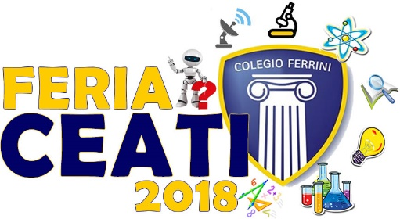
STUDENTS: _____________________________________ GRADE: 4 COURSE: _____________

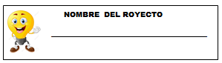
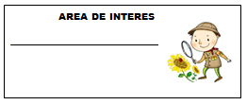

PROJECT SLOGAN
__________________________________________________________________________________________________________________________________________
PROJECT LOGO

What is its contribution to my life?
________________________________________________________________________________________________________________________________________________________________________________________________________________________________________________



What do I need?
__________________________________________________________________________________________________________________________________________________________________________________________________________________________________________________________________________________________________________________________________________________________________________________________________________________________
How is it built?
________________________________________________________________________________________________________________________________________________________________________________________________________________________________________________________________________________________________________________________________________________________________________________________________________________________________________________________

“It seems like magic…
But is science and technology”



