Android
IOS stands for iphone operating system  Operating system of Apple for its handheld.  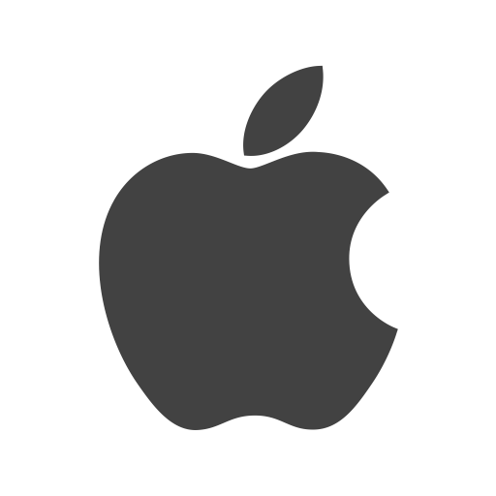    Developed by  Apple in 2007  - iPhone  - iPad  - iPod | 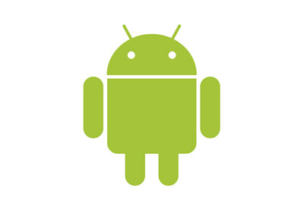  For mobile devices such as smartphones and tablets.  - Nokia  - Motorola  - Samsung  - LG  Open-source Operating System  Developed by Google in 2008
iOS

